Pune District Education Association’s
Seth Govind Raghunath Sable College of Pharmacy, Saswad
Activity Report
Title of the Event: Elocution Competition
Name of activity: Environmental Awareness Week
Date and Day: 08/02/2024 Thursday Time: 03:00 pm to 04:30pm

College has organized Elocution Competition on the occasion of “Environmental Awareness Week” on 08th February 2024 at 03.30 p.m. The Elocution Competition was organized for the students of D. Pharm, B. Pharm & M. Pharm Students.
Total 16 participants participated in the competition. The competition was co-ordinated by Mr. Jitendra Shinde under the guidance of Principal Dr. R. S. Chavan

Mr. J.V.Shinde Dr. Rajashree Chavan
Co-ordinator Principal

Elocution Competition 9th February 2024
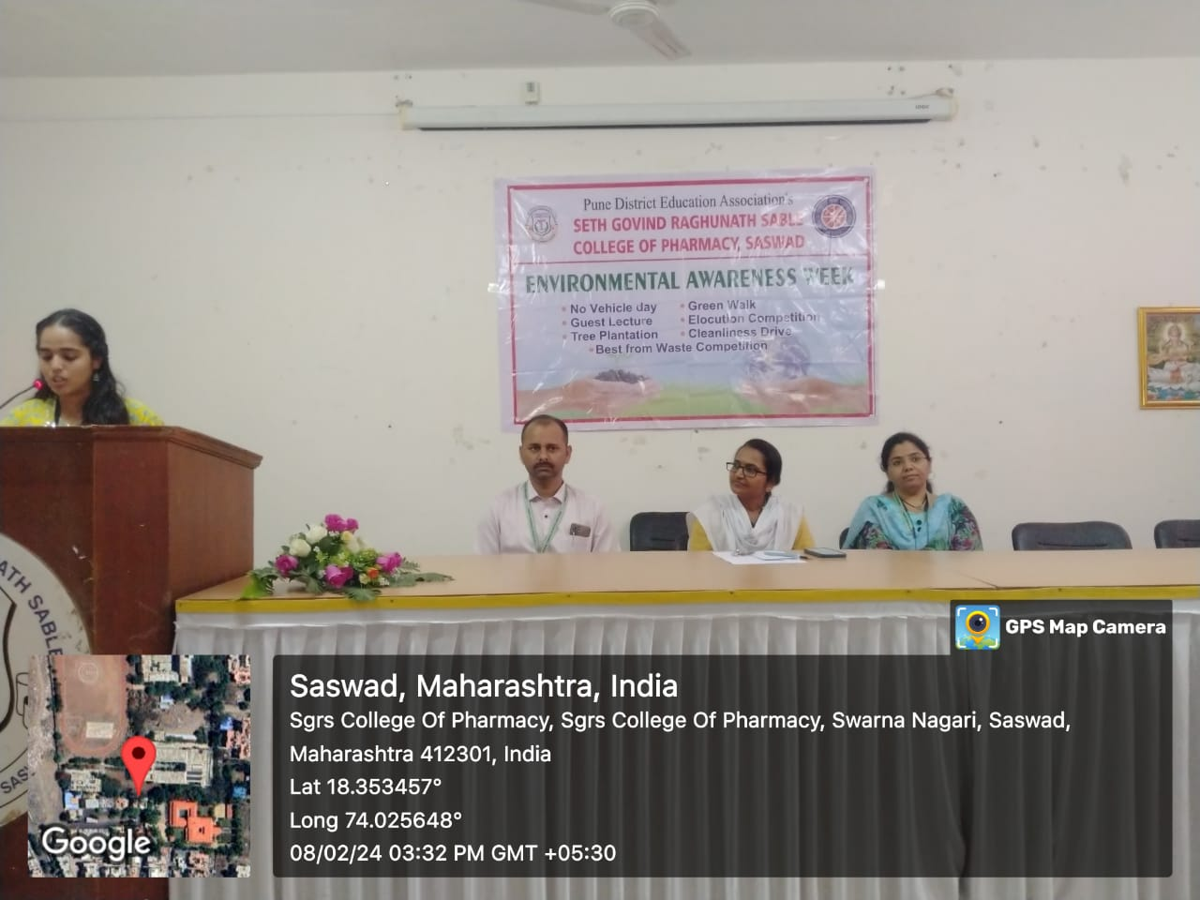

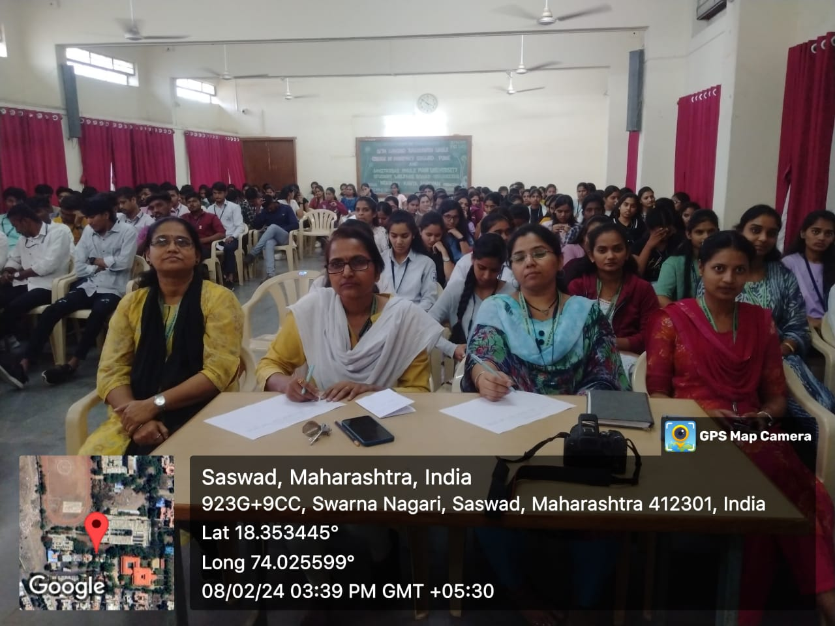

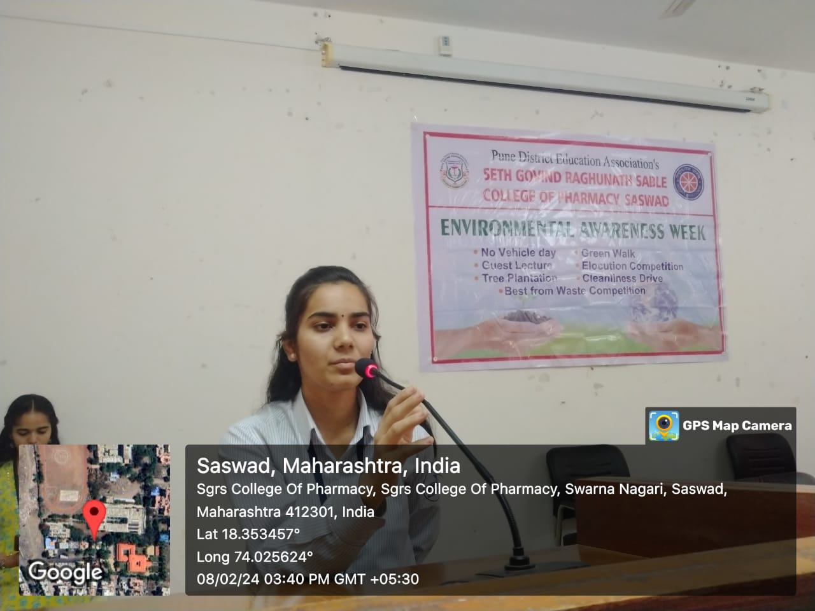

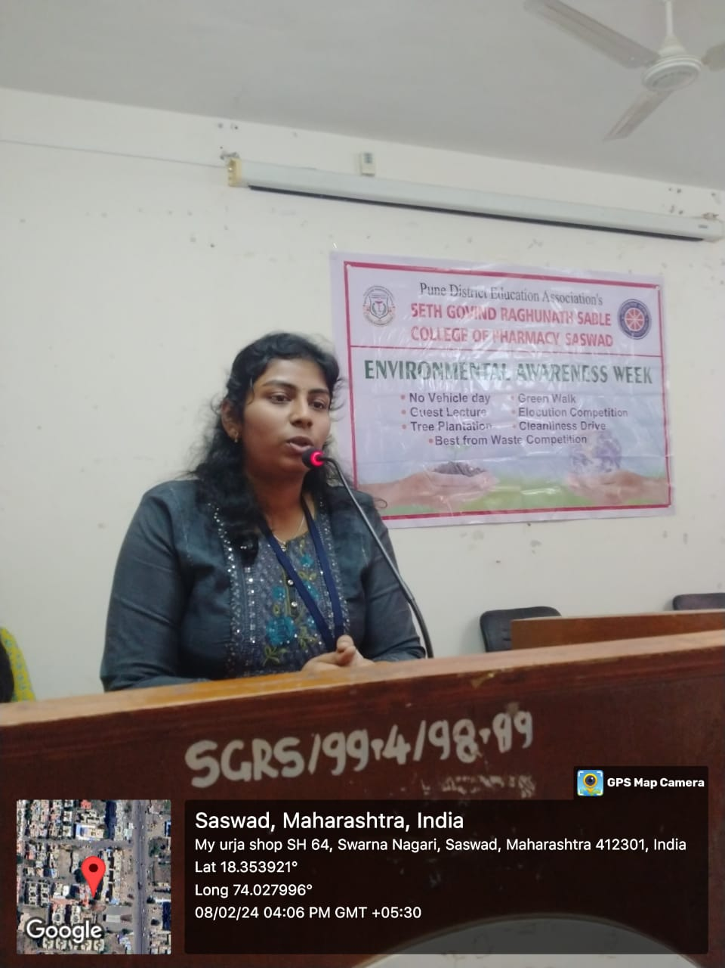

Dr. Rajashree Chavan
Principal

